# Updating Student Progress in Coassemble

This procedure extracts data from the Coassemble platform and allows pasting into Excel for more comprehensive oversight of progress.

1. Open the Coassemble course (for instance OLY24 - Wilderness Navigation at [https://mountaineers.coassemble.com/#/course/141688/overview](https://mountaineers.coassemble.com/%23/course/141688/overview)).
2. Click on the Course Report button in the top line icon bar. 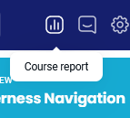
3. Click on the group name **OLY NAV SPRING 2024**
4. Click on the Reports button on the left panel.
5. Select “Results” from the Reports drop-down at upper-left.
6. Filter the Course to the correct course, for example OLY-Wilderness Navigation.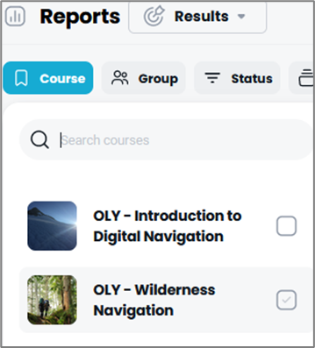
7. Filter the Group to OLY NAV Spring 2024.
8. At this point, you can review the results.
9. You can also Export the results to a CSV file, which can be copied into Excel.
10. The CSV file has more detail than needed or useful, so I recommend keeping only the rows with Column F Resource type = “Course.”
11. The most useful columns, besides Learner’s name, Username (email), Commenced, and Completed are:
    1. Progress (0-100) shows the student’s progress through the material, *not including the assignments*.
    2. Grade (0-100) shows the students score *only on* *the assignments completed*. So if an assignment hasn’t been completed, then it doesn’t show in this value.
    3. Pass/Competent shows “Yes” when *all of the material and the assignments* have been completed and “No” until then.
12. Evaluating a student’s completion starts with the Pass/Competent column, followed by a look at the Progress column and then a look to see if the student has completed the assignments.